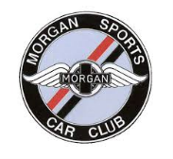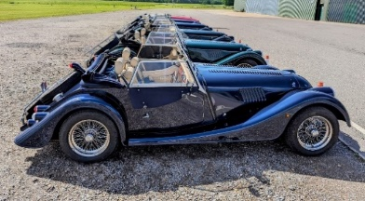

Hopmog & The MSCC Board invite you to a one-off event at The Great Danes Hotel In Kent, ‘The Garden of England’

Full Weekend double occupancy - £200.98 (inc. £1.75 booking fee)
Enjoy a warm welcome with arrival on Friday
Please note: This package is priced per person.
Full weekend Single Occupancy - £299.98 (inc. £1.75 booking fee) Friday to Sunday
Saturday Night Only Double Occupancy - £110.20 (inc. £1.75 booking fee)
Enjoy a warm welcome with arrival on Saturday
Please note: This package is priced per person.
Saturday Night Only Single Occupancy - £159.70 (inc. £1.75 booking fee)
Enjoy a warm welcome with arrival on Saturday
Gala Dinner Dance Only - £50.25 (inc. £1.75 booking fee) per person
Indulge in a gala dinner accompanied by lively disco entertainment on Saturday night. Please note, this package includes dinner only—no accommodation is needed or provided.
BBQ Dinner Only - £36.75 (inc. £1.75 booking fee) per person
Delightful BBQ dinner on Friday night. Please note, this package includes dinner only—no accommodation is needed or provided.
- This is an online-only booking process for the 2027 event
- Please email us with your seating preferences or [click here]
- If you have any difficulty booking or anything else at all, any questions then please do not hesitate to contact the Hopmog organisers: - Stephen & Sharon Rose, contact details are below:
Stephen – events@hopmog.com /+44(0)7853 747914
Sharon – sharondrose1963@gmail.com / +44(0)7983 939811
A £50pp DEPOSIT SECURES YOUR PLACE
PLEASE SEE MSCC or HOPMOG EVENTS PAGES for DETAILS
Contact Steve Rose (events@hopmog.com 07853 747914) if you require help

A range of affordable & flexible packages are detailed below, and we urge you to book early to secure your rooms (a small deposit secures).

Go to MSCC or Hopmog Events pages to select the option that suits you best and make your booking
Join us for an unforgettable weekend hosted by Hopmog (MSCC South East Centre) at The Great Danes Hotel in Maidstone, Kent, from April 2nd to 4th, 2027. This exclusive event promises a perfect blend of relaxation, celebration, and networking with fellow enthusiasts. Friday Evening: A private BBQ dinner—unwind, enjoy great food, and connect with friends in a welcoming atmosphere. Saturday Morning: Start your day with a delicious buffet breakfast in a private room—Midday & Afternoon: Enjoy some leisure time until lunch, then participate in the MSCC AGM, running until 17:00. After a brief rest, prepare for the highlight of the weekend—a spectacular combined Hopmog & MSCC Dinner Dance celebrating 2027. Dance the night away, raise your glasses, and create memories until midnight in a lively, festive setting. Sunday Morning: Relax and unwind with a sumptuous buffet breakfast in a private room, wrapping up an incredible weekend of camaraderie and celebration. Don’t miss this fantastic opportunity to be part of a special event filled with fun, friendship, and festivities. Reserve your place now and make memories that will last a lifetime!
SIX BOOKING OPTIONS ARE AVAILABLE A £50pp DEPOSIT SECURES YOUR PLACE
PLEASE SEE MSCC or HOPMOG EVENTS PAGES for DETAILS
Contact Steve Rose (events@hopmog.com 07853 747914) if you require help

