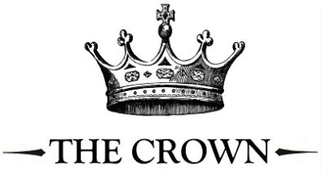**Starters**

Breaded Brie Wedges with cranberry sauce £8.5

Duck Spring Rolls with Asian sauce £7.5

French Onion Soup under croutons and melted cheese £7.5

Chicken Liver Parfait with red onion marmalade and warm bread £8.5

Cheese Soufflé with a mixed salad £8.5

**Main Courses**

Roast Leg of Lamb served with roast potatoes, cauliflower cheese, red cabbage, carrots, seasonal greens, Yorkshire pudding, mint sauce and gravy £19.5

Roast Beef with roast potatoes, cauliflower cheese, red cabbage, carrots, seasonal greens, Yorkshire pudding, horseradish sauce and gravy £21.5

Roast Pork Loin with roast potatoes, cauliflower cheese, red cabbage, carrots, seasonal greens, Yorkshire pudding, apple sauce and gravy £18.5

The Crown’s Mushroom Wellington with roast potatoes, cauliflower cheese, red cabbage, carrots, seasonal greens, Yorkshire pudding and veggie gravy £18.5

Crown Bacon Cheeseburger served with French fries, mixed salad and coleslaw £18.5

Chicken Schnitzel with garlic butter served with cauliflower cheese, garden peas and French fries £18.5

Beer Battered Haddock with hand cut chips, tartare sauce and garden peas £18.5

(v) Baked Aubergine with Goat’s Cheese served with sweet potato fries and a mixed salad £17.5

Parmesan Crusted Salmon Fillet served with parmentier potatoes and tender stem broccoli £19.5

**Desserts**

Biscoff Cheesecake with honeycomb ice cream £8.5

Chocolate Brownie with chocolate sauce and vanilla ice cream £8.5

Crème Brulée with homemade shortbread £7.5

Lemon Posset with homemade shortbread £7.5

The Crown’s Cheese Board

Lincoln Blue, Granarolo Brie, Dambuster Cheddar served with crackers, celery, grapes and damson & apple chutney £11.5

Selection of ice cream   
(Honeycomb, Belgian Chocolate, Stem ginger, Strawberry, Vanilla – Mango, Lemon or Raspberry Sorbet)

1 Scoop 2.50 2 Scoop 5.00 3 Scoop 7.00

**Selection of Hot Drinks available;**  
Cappuccino, Latte, Flat White, Americano, Espresso, Hot Chocolate, Tea (English Breakfast, Earl Grey, Citrus Chamomile, Green Tea, Herbal)

We separate ingredients, clean down work areas & equipment however the presence of allergenic ingredients means we cannot guarantee our food or drink are free from these ingredients. Please let our staff know if you have any allergies before you place an order.